Greensheets Document Checker
Testing Procedure

Objective
The purpose of this document is to describe the steps involved in testing the Greensheets Document Checker application in TEST environment.

Migration Procedure
The Greensheets Document Checker application is developed on the developer’s local PC and migrated to TEST environment that is set up on the machine app1-as1-test.

The Greensheets Document Checker application is a stand alone Java application that is scheduled to run daily at mid night as a batch job. So it cannot be tested using the web browser. So the tester needs to log on to the machine where the application is installed.

The System Administration advises us to download (from http://www.chiark.greenend.org.uk/~sgtatham/putty/) install the PuTTY SSH client on the local machine to connect to the server above.

First create a session to app1-fs1.

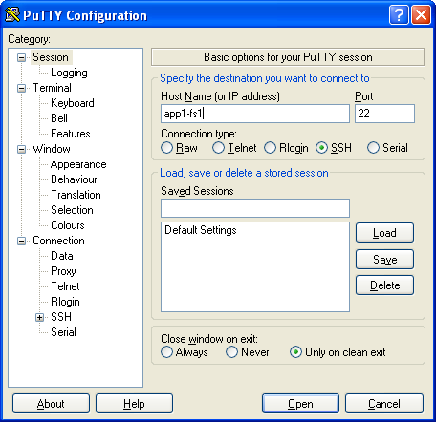

Fig 1: Open a session to app1-fs1.

Once that session is created create another putty session to app1-as1-test.nci.nih.gov with another set of username and password.

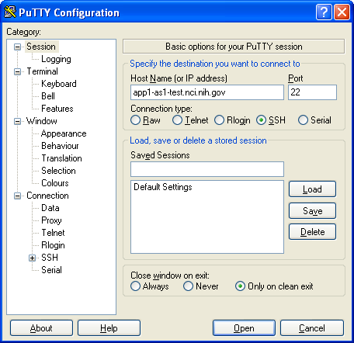

Fig 2: Open a session to app1-as1-test.

Get the user IDs/Passwords from the Project Manager.

Once the application is installed in the TEST server, the developer will let the tester know where the application is installed.

Assume that the Greensheets Document Checker v2.0.0 is installed in /usr/local/gsdoc_v2.0.0.

Change your working directory as follows:
cd /usr/local/gsdoc_v2.0.0

Create an environment variable as follows:
export DOCDEPJARS="lib/dataretriever.jar:lib/log4j-1.2.13.jar:lib/commons-io-1.2.jar:lib/ojdbc14.jar:lib/itext-1.4.5.jar:lib/commons-configuration-1.3.jar:lib/commons-lang-2.2.jar:lib/commons-digester-1.7.jar:lib/commons-beanutils-core.jar:lib/commons-collections-3.2.jar:lib/commons-logging-1.1.jar:lib/mail.jar:lib/activation.jar"

The above command should be typed in a single line without breaking into multiple lines.

Now type in the command to execute the application as follows:
/usr/java/j2sdk1.4.2_11/bin/java -Xms512m -Xmx1024m -classpath .:$DOCDEPJARS gov.nih.nci.iscs.numsix.apps.docchecker.DocChecker

The above command should also be typed in a single line without breaking into multiple lines.

FAQ

If you receive any error, you need to contact the developer with the error message. There could be few reasons:

1.
Problem: The JRE may haven been removed from the test box.
Solution: Work with the developer and find out the JRE installation directory.

2.
Problem: The application itself may not be installed correctly in the directory where you changed your current working directory to.
Solution: Change to the correct directory where the Document Checker is installed.

3.
Problem: The report file may have become huge.
Solution: Change the JVM arguments you specified on the command line. Discuss the issue with the developer.
-Xms512m -Xmx1024m

The complete syntax is given above.

4.
Problem: The email is not sent to your Inbox and goes to someone else’s Inbox.
Solution: Change the conf/config.xml file to modify the test conditions.

Ensure that the configuration properties are correct for the target environment. Typically, it is as shown here. Please do not change the environment settings to connect to Production. You are supposed to test only in the TEST box.

<running-env>TEST</running-env>

<environment>
<description>Test environment</description>
<disk-location>/data/test/greensheets/</disk-location>
<db-prefix>/data/test/greensheets/</db-prefix>
<report-loc>/data/test/greensheets/filecomparison/</report-loc>
</environment>

<report>
<!--
Specify a date for the report-last-run element in the format of DD-MON-YYYY if the report type is INCREMENTAL.
-->
<description>
report-type element can take on either INCREMENTAL or FULL.
</description>
<!-- <report-type>FULL</report-type> -->
<report-type>INCREMENTAL</report-type>
<report-last-run>04-Jun-2007</report-last-run>
</report>
<report-recipients>
<sender>nciweb@mail.nih.gov</sender>
<subscribers-email>kparrott@numbersix.com</subscribers-email>
<subscribers-email>xyz@atsva.com</subscribers-email>
<subject>Greensheets Attachments Reconciliation Report</subject>
</report-recipients>

